**Power BI Assignment 5**

1. **Explain DAX.**

DAX is a collection of functions, operators, and constants that can be used in a formula, or expression, to calculate and return one or more values. Stated more simply, DAX helps you create new information from data already in your model.

**Importance of DAX**

It’s easy to create a workbook and import some data into it. You can even create PivotTables or Pivot Charts that display important information without using any DAX formulas. But, what if you need to analyse critical sales data across several product categories and for different date ranges? Or, you need combine important inventory data from several tables in different data sources? DAX formulas provide this capability and many other important capabilities as well. Learning how to create effective DAX formulas will help you get the most out of your data. When you get the information you need, you can begin to solve real business problems that affect your bottom line. This is Business Intelligence, and DAX will help you get there.

1. **Explain datasets, reports, and dashboards and how they relate to each other?**

Dashboards are created from multiple datasets or reports. Dashboards always concentrate on building insights into the data by using graphs, attractive visuals, charts, etc. Reports are not concentrated on the visualization part of the data rather it looks to create summary pages and

Reports are created from a single dataset.

1. **How reports can be created in power BI, explain two ways with Navigation of each.**

Create a report from an Excel file in the Power BI service.

* Prepare your data in Excel.
* Download sample data.
* Build a report in the Power BI service.
* Pin the report visuals to a dashboard.
* Share a link to the dashboard.
* Share the dashboard in Microsoft Teams

Create a report quickly from a SharePoint list or library.

* Determine what information you want to show in the report or scorecard.
* Identify the data sources that you want to use. ...
* Choose the report creation tool that you want to use. ...
* Create the report, and save it to a site such as a Business Intelligence Centre site.

1. **How to connect to data in Power BI? How to use the content pack to connect to google analytics? Mention the steps.**

With Power BI Desktop, you can connect to many different types of data. These sources include basic data sources, such as a Microsoft Excel file. You can connect to online services that contain all sorts of data, such as Salesforce, Microsoft Dynamics, Azure Blob Storage, and many more.

To connect to data, from the Home ribbon select Get data.

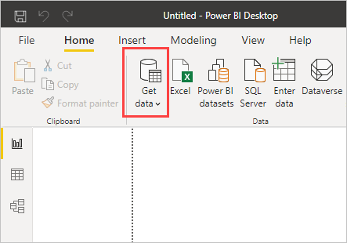

The Get Data window appears. You can choose from the many different data sources to which Power BI Desktop can connect.

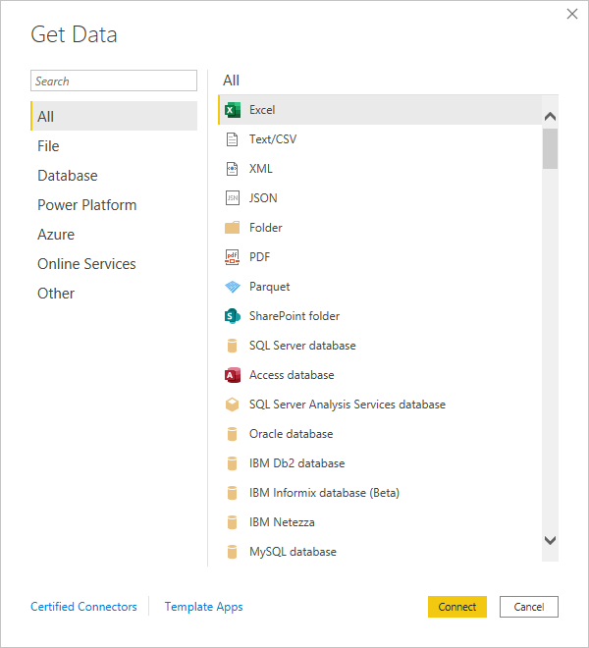

In Power BI, it’s straightforward to connect to the Google Analytics content pack.

1. Launch Power BI Desktop. On the ribbon, in the External Data group, click Get Data.

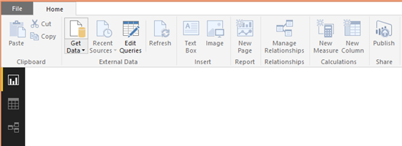

1. From the drop-down menu, click More…

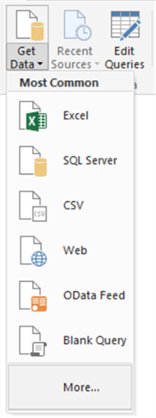

1. In the Get Data window, click Other. From the list of other data sources, click Google Analytics, and then click Connect.

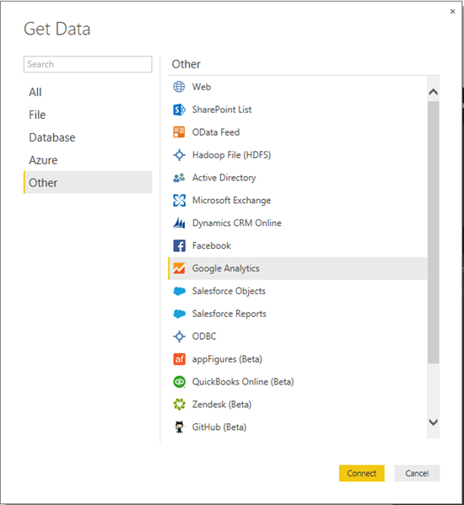

1. 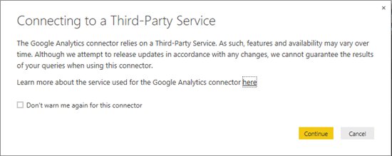Read the information about connecting to a third-party service, and then click Continue.
2. Google Analytics asks Power BI Desktop for permission to connect to your data. Click Accept.

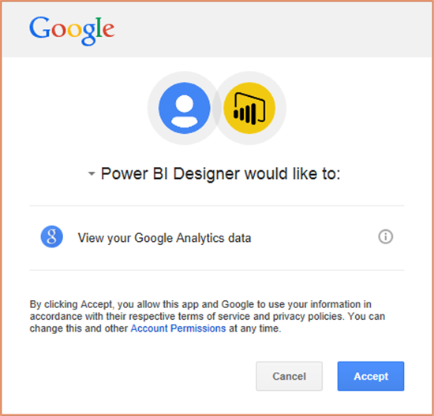

1. Power BI Desktop shows that you’re signed in to Google Analytics. To load your Google Analytics data, click Connect.

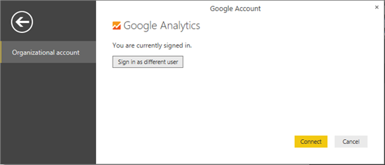

1. Power BI Desktop loads the Google Analytics data. Now you can start creating your amazing dynamic reports

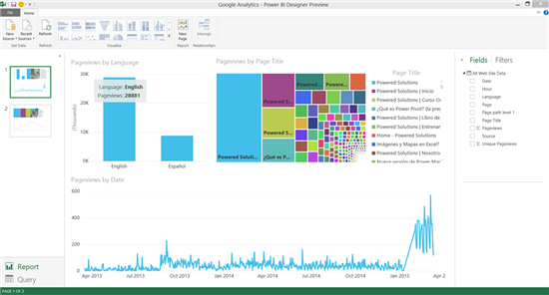

1. **How to import Local files in Power BI? Mention the Steps.**

For Manually importing data to Power BI

* Click the Get Data in the lower left screen.
* Under Import or Connect to Data > Files, click Get.
* Click Local File.
* Choose which file to upload and click Open.
* Click Upload under Upload your Excel file to Power BI.
* The message “Your file has been uploaded” should appear.

1. **In Power BI visualization, what are Reading View and Editing view?**

The Power BI service has two different modes for interacting with reports:

* Reading view

Reading view is your way to explore and interact with reports created by colleagues.

In Reading view, the content isn't static. You can dig in, looking for trends, insights, and other business intelligence.

* Editing view

Editing view is used by report designers, who create the reports and share them with you.